DTI5126 / IAI 5120 / SYS 5170
Applied Data Science - Midterm Report

Student Performance Analysis
Group #10
October 24th, 2025

Name | Contribution
Maria Arias | Preprocessing
Nouf Almudlej | Visualisations and stats
Wenkang Liu | Visualisations
Amal Hussein | Report - Purpose, Data exploration and next steps
Adjmal Younoussa | Report - Preprocessing and next steps
Juan Hiedra Primera | Report review, formatting

Purpose and Scope

This report assesses our dataset’s suitability and presents interim results from exploratory analysis and preprocessing. Our study examines how invariant factors (e.g., parental education) and variant factors (e.g., study time, absences) relate to student achievement, with a practical aim: early identification of at-risk students and guidance on feasible supports.

Data exploration
We began with a descriptive review of the data. Because we merged two subject files, each feature appears twice, _x for Math and _y for Portuguese. For example, G3_x is the Math value and G3_y is the Portuguese value. Our main outcome for exploration is G3, the final course grade on a 0-20 scale (with 10 as the pass threshold). We treat G3 as the result of interest and examine how other variables relate to it. For context, G1 and G2 are the first and second period grades on the same 0-20 scale; we mention them for clarity, but they are not analyzed in this report. We also examined absences (count of missed classes, roughly 0-93), studytime (ordinal 1-4: 1 = <2 hours/week, 2 = 2-5, 3 = 5-10, 4 = >10), and self-reported alcohol use via Dalc (workday consumption) and Walc (weekend consumption), each on an ordinal 1-5 scale (1 = very low to 5 = very high). Family background variables include Medu and Fedu, the mother’s and father’s highest education (0 = none; 1 = primary/4th; 2 = 5th-9th; 3 = secondary; 4 = higher), and Mjob/Fjob, parent job categories (teacher, health, services, at_home, other). We also use failures to denote the number of past class failures (0; 1-3; or 4 indicating three or more) and school to distinguish campuses (Gabriel Pereira or Mousinho da Silveira).
With those definitions in place, we inspected histograms and boxplots for G3, absences, studytime, and the alcohol items. Grades were unimodal and clustered near the pass threshold (10/20). Absences were strongly right-skewed, with a few students missing far more classes than the rest. Studytime concentrated at levels 1-2 (under five hours per week). For Dalc and Walc, most students reported 1-2, with only a handful at 4-5, so the high end is thin.

From there, we examined relationships that matter for risk identification. As absences rose, G3 tended to fall; the boxplots showed long tails, so we plan to handle extreme values carefully in preprocessing. Past failures were linked to lower G3, but our bubble plot (point size proportional to studytime) suggested that more studytime partially offsets that penalty, and students with failures who also report higher studytime cluster at higher final grades. Studytime itself showed a clear monotonic pattern: higher levels lined up with higher median grades in both subjects. As for family background, parental education (Medu and Fedu) showed a positive gradient for Math and Portuguese. By contrast, parental jobs (Mjob and Fjob) showed smaller differences, with at_home tending lower in Math and little separation in Portuguese. Math averages look different (Gabriel Pereira ≈ 10.49 vs Mousinho da Silveira ≈ 9.47), but this gap is not statistically reliable; Welch’s t-test was not significant (p = 0.197). All in all, Math performance appears similar across the two schools, and detecting a small true gap, if any, would likely require more data. Finally, our correlation heatmap supported these patterns: the failures variable was negatively related to final grades, while studytime and parental education were positive.
All supporting plots and figures that illustrate these points are included below.

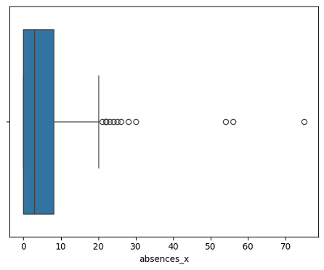
Figure 1. Boxplot — Math absences (absences_x). Long right tail and several extreme values.
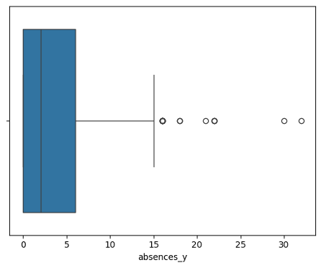
Figure 2. Boxplot — Portuguese absences (absences_y). Similar shape with math absences a slightly shorter tail.

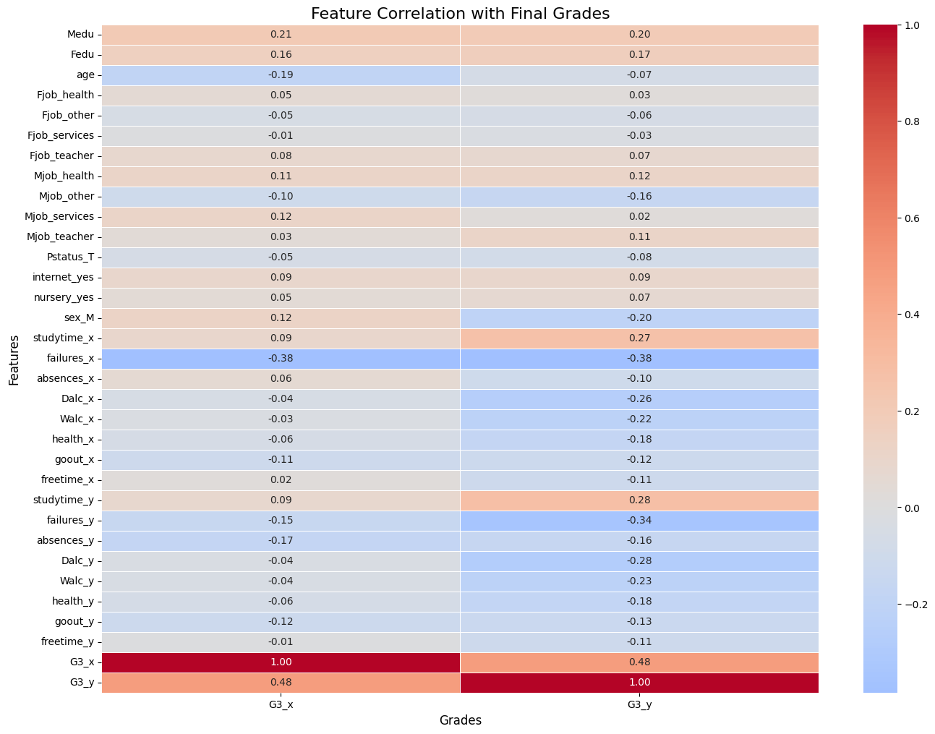

Figure 3. Correlation with final grades (selected features). Failures correlate negatively; studytime and parental education positively.
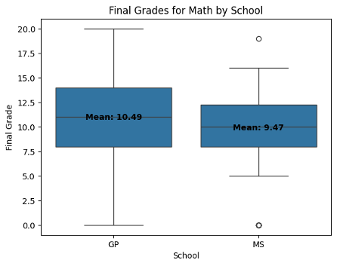
Figure 4. Final grades (Math) by school. Mean GP = 10.49, MS = 9.47; Welch t‑test not significant (p = 0.197).
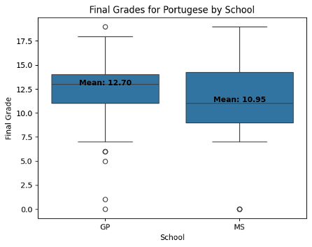
Figure 5. Final grades (Portuguese) by school. Visual gap is larger.
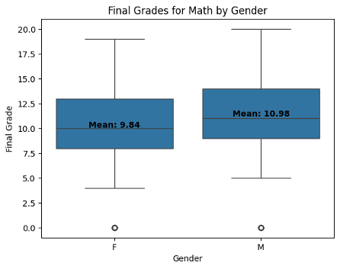
Figure 6. Math grades vs study time (1=<2h … 4=>10h). Monotonic upward pattern.
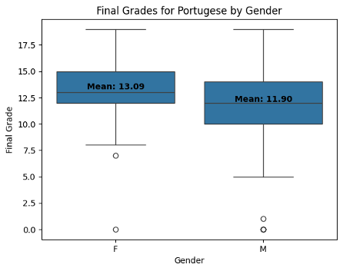
Figure 7. Portuguese grades vs study time. Similar monotonic pattern.

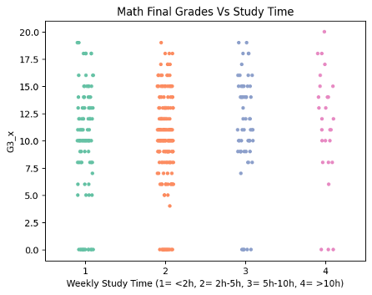
Figure 8. Math grades vs past failures (violin). Performance drops and dispersion increases with more failures.
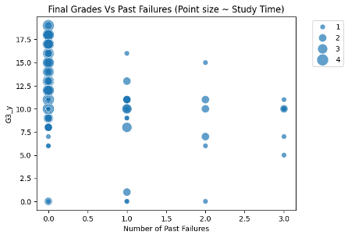
Figure 9. Portuguese grades vs past failures (point size ∝ study time). Higher study time partly offsets the penalty of past failures.
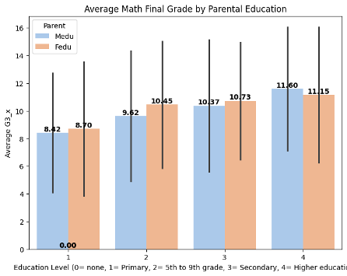
Figure 10. Average Math grade by parental education (Medu/Fedu). Clear positive gradient across education levels.
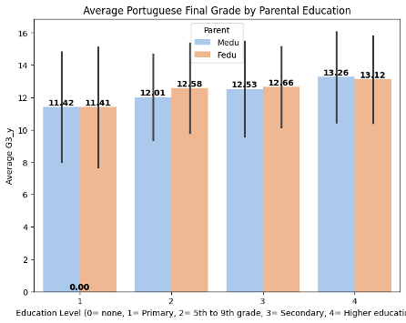
Figure 11. Average Portuguese grade by parental education (Medu/Fedu). Similar positive gradient.

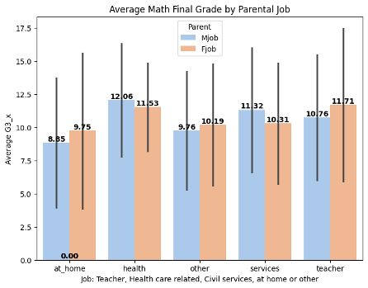
Figure 12. Average Math grade by parental job (Mjob/Fjob). Smaller differences than education; 'at_home' tends lower for Math.

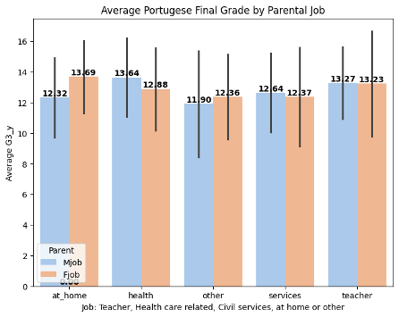
Figure 13. Average Portuguese grade by parental job (Mjob/Fjob). Differences are modest relative to education.
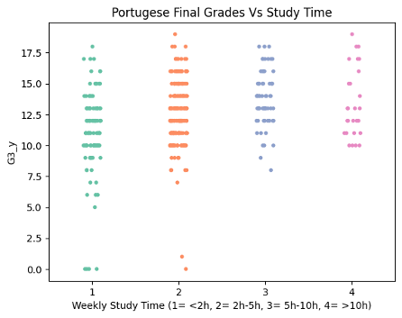
Figure 14. Protegues Final grades by study time. Slight increase in final grade with study time

Preprocessing steps
Data cleaning
Given that 382 students appear in both datasets, we merged the Math and Portuguese files to isolate this shared subset. These students were identified by searching for matching attributes that uniquely define each individual. We did an inner join of the math and Portuguese datasets on invariant student attributes (school, sex, age, etc.) to keep only students present in both.
We ran a cross-consistency check on fields duplicated by the merge—specifically guardian and weekday alcohol use (Dalc)—by comparing the Math and Portuguese responses for the same students. This was to detect conflicting self-reports across the two surveys and avoid silently mixing incompatible values. The check found disagreements (6 rows for guardian, 5 for Dalc), so we chose not to consolidate them into a single column. Instead, we keep both versions and treat them separately in the analysis.
We converted the final grades (G3_x for Math, G3_y for Portuguese) into binary “at-risk” targets using pass or fail cutoff of 10/20: at_risk_math and at_risk_port are 1 if the student’s final grade is <10, else 0. Then we built a combined label, at_risk_total , to summarize each student’s status across subjects and to visualize class distribution. This preprocessing simplifies the problem into a classification task, makes outcomes interpretable for stakeholders, and lets us quickly assess class balance before modeling.
Missing values
The merged dataset does not have missing values (no null nor NA values). We checked this by running the following code :
# Comptes par colonne
student_merged.isnull().sum()
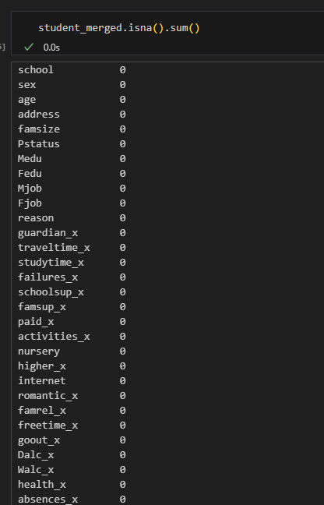
na_like = ['','NA','N/A','None','na','n/a']
for c in student_merged.select_dtypes(include='object'):
print(c, student_merged[c].isin(na_like).sum())

Outliers
After merging, we diagnosed outliers by computing ranges and variances and plotting boxplots for absences_x (from the math dataset) and absences_y (from the portuguese dataset). Then we capped both at the 95th percentile to reduce the influence of extreme values and make future models more robust.
Encoding
We identified all categorical fields by subtracting numeric columns from the full column list, then one-hot encoded those categories. This converts non-numeric features into clean 0/1 indicators, making the data usable for models that require numeric inputs without imposing a fake ordering on categories. Finally, we cast the encoded DataFrame to “int” to ensure consistency.
Progress update

What we have completed

- We merged the two subject files to obtain the matched cohort of 382 students and verified the attributes we need for variant and invariant analyses.
- We confirmed that there are no source-level missing values. We did find minor cross-subject inconsistencies for the same students, such as a few differences in guardian responses (6 rows) and weekday alcohol Dalc (5 rows). We documented these and treated them as subject-specific answers.
- We completed exploratory analysis and produced descriptive statistics and figures focused on the final grade, G3 as the outcome, and examined relationships with absences, study time, parental education, parental jobs and school. This aligns with our proposal’s focus on variant and invariant drivers. All figures are saved and referenced in the Data Exploration section.

Next Milestones

- Supervised learning: implement the Random Forest Regressor to predict final grades. Then, we can use the RF classifier and KNN to classify if a student is at risk.
- Unsupervised learning: using K-Means Clustering we will segment students to reveal profiles. This will help us to guide targeted interventions on student and resource allocation.
- Classification models: train and assess classification models with cross-validated confusion matrices, F1, and ROC-AUC to account for class imbalance. If results are limited, we will apply targeted feature engineering and re-evaluate.
- Data preparation: several issues were identified as needing to be addressed as we progress:
  - Simple one-hot encoding is not ideal for every feature; job categories (Fjob, Mjob) contain several small levels, which can fragment the data and inflate variance. We will pool rare levels into an “other” bucket and one-hot encode the remaining levels so the design matrix stays stable.
  - For strictly ordinal fields such as traveltime, studytime, failures, Dalc, Walc, famrel, freetime, goout, and health, we will keep the integer codes to preserve rank information. This keeps ordering intact, reduces unnecessary parameters, and makes effects easier to interpret.
  - Binary text fields (sex, address, famsize, Pstatus, nursery, internet, and the support flags) will be mapped to 0 and 1.
  - Continuous counts like absences and age will remain numeric.
- Feature validation: validate these choices and report whether they improve early risk prediction.

